

Bangladesh University Of Business and Technology (BUBT)

Advanced Programming Lab
Course code: CSE 332
Lab Assignment 2

Submitted by:
Name: Anayat Hossain
ID: 21225103161
Section: 04
Intake: 49

Github Link:
https://github.com/AnayatHossain/Java-Lab-Assignment-2

Submitted to:
Md. Mahbubur Rahman
Assistant Professor, Dept. of CSE, BUBT
1. Write a java program to show No- Arguments Constructor.

Code:

public class NoArgumentsConstructor {

public NoArgumentsConstructor() {
System.out.println("It's a No Arguments Constructor.");
}

public static void main(String[] args) {
NoArgumentsConstructor a = new NoArgumentsConstructor();
}}

Output:

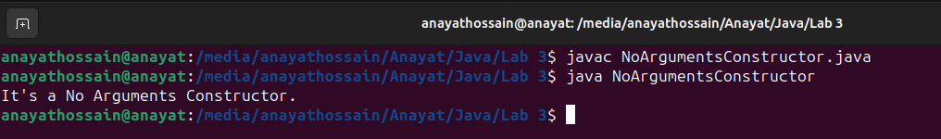
2. Write a Java code to display parameterized Constructor in java.

Code:

public class ParameterizedConstructor {
static int value;

public ParameterizedConstructor(int a) {
value = a;
System.out.println("Parameterized Constructor is " + a);
}

public static void main(String[] args) {
ParameterizedConstructor obj = new ParameterizedConstructor(13);
}
}

Output:

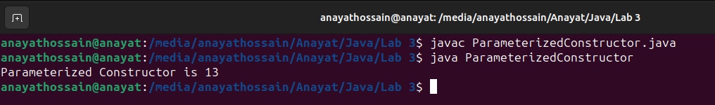

3. Write a Java code to copy a constructor by another Constructor.

Code:

public class CopyConstructor1 {

int value;

public CopyConstructor1(int a) {
value = a;
System.out.println("Original constructor called with value: " + a);
}

public CopyConstructor1(CopyConstructor1 m) {
value = m.value;
System.out.println("Copy constructor called with value: " + value);
}

public static void main(String[] args) {
CopyConstructor1 c1 = new CopyConstructor1(20);
CopyConstructor1 c2 = new CopyConstructor1(c1);
}
}

Output:

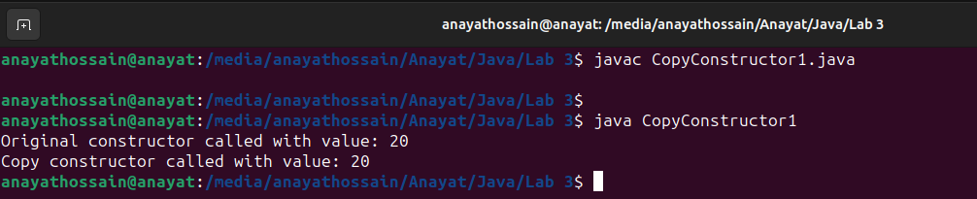

4. Write a Jva code to copy a constructor by assigning the values of one object into another.

Code:

public class CopyConstructorAssignValues {
int value;

public CopyConstructorAssignValues(int v) {
value = v;
System.out.println("Original constructor called with value: " + v);
}

public CopyConstructorAssignValues(CopyConstructorAssignValues a) {
value = a.value;
System.out.println("Copy constructor called with value: " + value);
}

public static void main(String[] args) {
CopyConstructorAssignValues c1 = new CopyConstructorAssignValues(13);
CopyConstructorAssignValues c2 = new CopyConstructorAssignValues(c1);
}
}

Output:

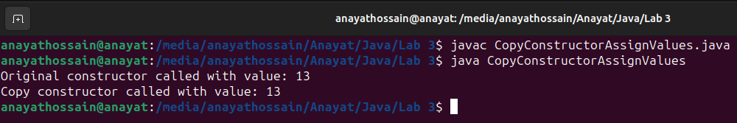

5. Write a Java program to find the addition of two number using JOptionPane class.

Code:

public class ConstructorCallingAnotherConstructor {
int value;

public ConstructorCallingAnotherConstructor() {
this(50);
System.out.println("No-arguments constructor called.");
}

public ConstructorCallingAnotherConstructor(int v) {
this.value = v;
System.out.println("Parameterized constructor called with value: " + v);
}

public static void main(String[] args) {
ConstructorCallingAnotherConstructor obj = new ConstructorCallingAnotherConstructor();
}
}

Output:

